SIMATS ENGINEERING (SAVEETHA SCHOOL OF ENGINEERING)
Department of Computer Science and Engineering
ASSESSMENT TOOL 3 – Comparative Analysis

Course Code: | CSA06 | Course Title: | Design and Analysis of Algorithms
CO Assessed: | CO4: Articulation (BL4, BL5) | Assessment: | Assessment Tool 3 – Comparative Analysis
Weightage: | 10% of CIA | Total Marks: | 100
CO4 Statement: | Solve optimization problems using dynamic programming and greedy strategies.
Student Name: | SRINIVASAN A | Reg. No.: | 192411025
Section / Batch: | 2024 | Date: | 22-08-2026
Instructions to Students

- Answer the following question. Total Marks: 100.
- Analyze the given questions thoroughly before answering.
- Compare multiple aspects such as methods, results, advantages, and limitations clearly.
- Critically evaluate the strengths, weaknesses, and implications with proper justification.
- Present meaningful insights, interpretations, and well-supported conclusions from the comparisons.

Question Type | Focus Area | Questions
Comparative Analysis | Comparative analysis of Dynamic Programming and Greedy algorithms for optimization problems. | Q1

SECTION A – Comparative Analysis

Code of Conduct
I SRINIVASAN A/192411025(Name / Reg No) certify that this submission is my original work and that I have adhered to the guidelines specified for this assessment. I understand that any violation of academic integrity rules will result in disciplinary action.
Signature of the Student: SRINIVASAN A

RUBRICS FOR CALCULATION

Comparative Analysis
Criteria | Weightage | Level 4 (Exemplary) | Level 3 (Proficient) | Level 2 (Developing) | Level 1 (Beginning)
Selection of Studies/Parameters | 20% | Selects highly relevant and diverse studies with  well-defined comparison parameters | Selects relevant studies with minor  gaps in parameter definition | Limited or partially  relevant selection | Poor or inappropriate  selection of studies
Comparison & Differentiation | 25% | Clearly compares multiple aspects (methods, results, limitations) with strong differentiation | Good comparison with minor gaps | Basic comparison  with limited depth | No clear comparison;  mostly descriptive
Critical Evaluation | 25% | Critically evaluates strengths, weaknesses, and implications with strong justification | Provides  evaluation with some justification | Limited  evaluation; lacks depth | No critical  evaluation provided
Synthesis & Insight Generation | 20% | Generates meaningful  insights and conclusions from comparisons | Some insights  derived from comparison | Limited or unclear insights | No insights generated
Clarity | 10% | Information is clearly presented (tables/figures) with logical structure | Generally clear with minor issues | Presentation lacks clarity or structure | Poor presentation and difficult to understand

Marks Evaluation:
Criteria | Wt. | Level 4 – Exemplary | Level 3 – Proficient | Level 2 – Developing | Level 1 – Beginning
Selection of Studies/Parameters | 20%
Comparison & Differentiation | 25%
Critical Evaluation | 25%
Synthesis & Insight Generation | 20%
Clarity | 10%
Total Marks (100):

Faculty In-charge | Course Coordinator | Head of Department
Name: | Name: | Name:
Signature: | Signature: | Signature:
Date: | Date: | Date:

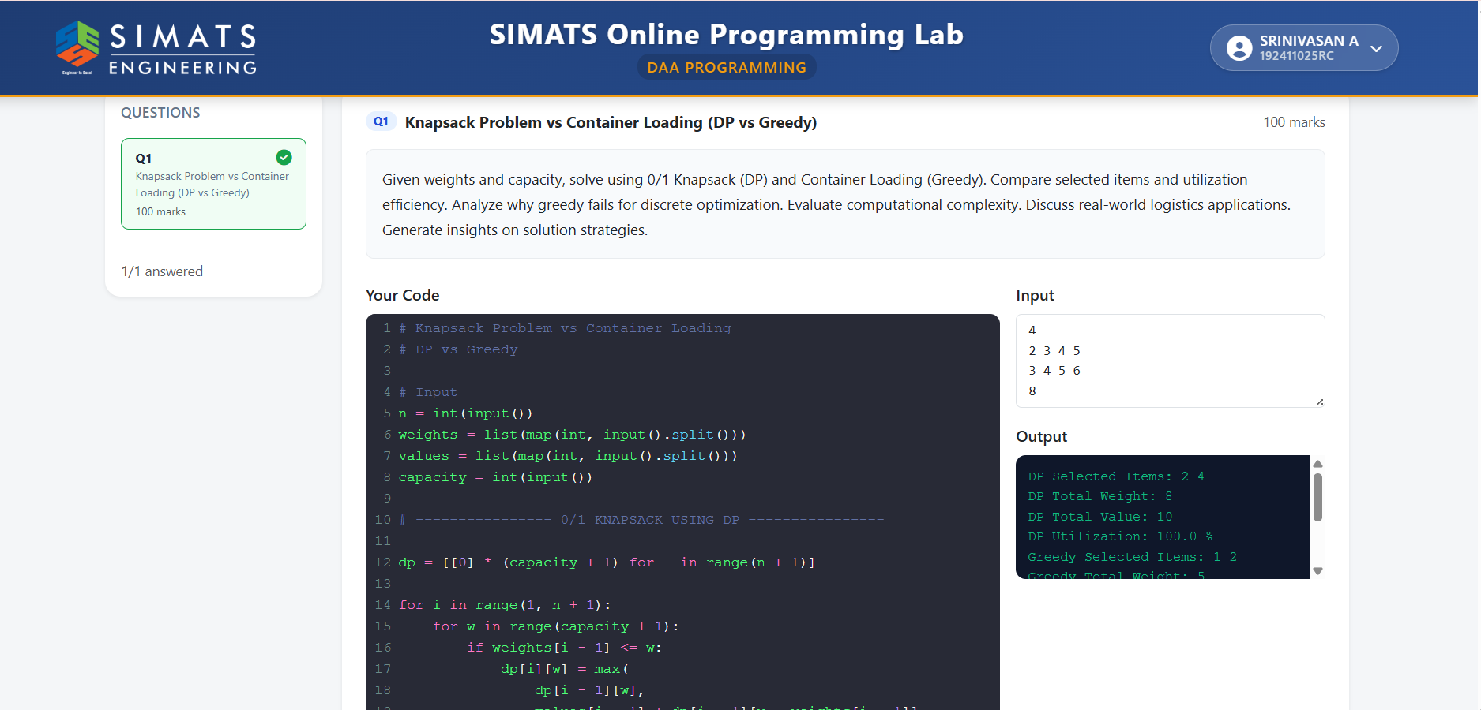

Algorithm: 0/1 Knapsack (DP) vs Container Loading (Greedy)
Step 1: Start.
Step 2: Read the number of items n.
Step 3: Read the weights, values, and container capacity.
Step 4: 0/1 Knapsack using DP
- Create a DP table of size (n+1) × (capacity+1).
- Initialize all values to 0.
- For each item i and capacity w:
  - If weight[i] <= w, choose the maximum of:
    - Excluding the item.
    - Including the item.
  - Otherwise, exclude the item.
- Backtrack through the DP table to find the selected items.
- Calculate total weight, total value, and utilization.
Step 5: Container Loading using Greedy
- Sort items based on their weight/value criterion.
- Start with total weight 0.
- Select items one by one if they fit within the capacity.
- Stop when no more items can be added.
- Calculate total weight, value, and utilization.
Step 6: Compare the DP and Greedy selected items and their values.
Step 7: Display the results and computational complexity.
Step 8: Stop.
Complexity:
- 0/1 Knapsack DP: O(n × C)
- Greedy: O(n log n) due to sorting.

